TITLE TITLE TITLE TITLE TITLE TITLE TITLE TITLE TITLE
Name Surnameª, Name Surname^{b}, Name Surnameª
ªDepartment of Pharmaceutical Chemistry, Faculty of Pharmacy, Biruni University, Istanbul, Turkey.
^{b}Department of Chemistry, Faculty of Science, Hacettepe University, Ankara, Turkey.
Presenting Authors’s E-mail: aece@biruni.edu.tr

ABSTRACT
Abstract abstract abstract abstract abstract abstract abstract abstract abstract abstract abstract. Abstract abstract abstract abstract abstract abstract abstract abstract abstract abstract abstract abstract abstract abstract abstract abstract.¹ Abstract abstract abstract abstract abstract abstract abstract abstract abstract abstract abstract abstract abstract abstract abstract abstract abstract abstract abstract abstract abstract abstract abstract abstract abstract abstract abstract abstract abstract abstract abstract abstract abstract abstract abstract abstract abstract abstract abstract abstract abstract abstract abstract abstract abstract abstract abstract abstract abstract abstract abstract abstract abstract abstract abstract abstract abstract abstract abstract abstract abstract. Abstract abstract abstract abstract abstract abstract abstract abstract abstract abstract abstract abstract abstract abstract abstract abstract abstract abstract abstract abstract abstract abstract abstract.²
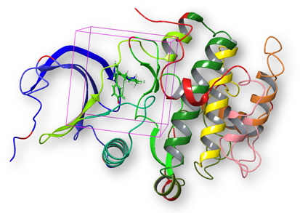
Figure 1. A schematic representation of a ligand-protein complex and binding site.

Abstract abstract abstract abstract abstract abstract abstract abstract abstract abstract abstract abstract abstract abstract abstract abstract.³ Abstract abstract abstract abstract abstract abstract abstract abstract abstract abstract abstract abstract abstract abstract abstract abstract abstract abstract. Abstract abstract abstract abstract abstract abstract abstract abstract abstract abstract abstract abstract abstract abstract abstract abstract abstract abstract abstract abstract abstract abstract abstract abstract abstract abstract abstract abstract abstract abstract abstract abstract abstract.

REFERENCES
- Ece, A. (2020). Towards more effective acetylcholinesterase inhibitors: a comprehensive modelling study based on human acetylcholinesterase protein–drug complex. Journal of Biomolecular Structure and Dynamics, 38(2), 565-572.
- Dizdaroglu, Y., Albay, C., Arslan, T., Ece, A., Turkoglu, E. A., Efe, A., ... & Ekinci, D. (2020). Design, synthesis and molecular modelling studies of some pyrazole derivatives as carbonic anhydrase inhibitors. Journal of Enzyme Inhibition and Medicinal Chemistry, 35(1), 289-297.
- Yamali, C., Sakagami, H., Uesawa, Y., Kurosaki, K., Satoh, K., Masuda, Y., ... & Gul, H. I. (2021). Comprehensive study on potent and selective carbonic anhydrase inhibitors: Synthesis, bioactivities and molecular modelling studies of 4-(3-(2-arylidenehydrazine-1-carbonyl)-5-(thiophen-2-yl)-1H-pyrazole-1-yl) benzenesulfonamides. European Journal of Medicinal Chemistry, 217, 113351.

